Information System Security Control

Computer security means to protect information. It deals with the prevention and detection of unauthorized actions by users of a computer. Lately it has been extended to include privacy, confidentiality, and integrity.

This definition implies that you have to know the information and the value of that information in order to develop protective measures. One also need to know to which individuals need unique identities and how much information may be divulged to the outside world. A rough classification of protective measures in computer security is as follows:

- Prevention :
Take measures that prevent your information from being damaged, altered, or stolen. Preventive measures can range from locking the server room door to setting up high-level security policies.

- Detection :
Take measures that allow you to detect when information has been damaged, altered, or stolen, how it has been damaged, altered, or stolen, and who has caused the damage. Various tools are available to help detect intrusions, damage or alterations, and viruses.

- Reaction :
Take measures that allow recovery of information, even if information is lost or damaged.

- Major Control Techniques :

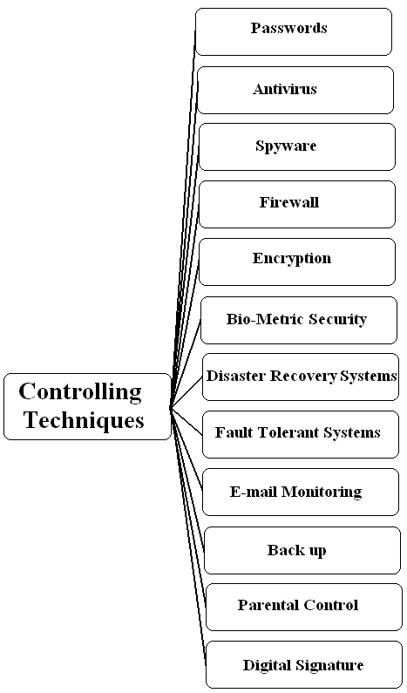

- Password :
A password is an unspaced sequence of characters used to determine that a computer user requesting access to a computer system is really that particular user. Typically, users of a multi-user or securely protected single-user system claim a unique name (often called a user ID) that can be generally known. In order to verify that someone entering that user ID really is that person, a second identification, the password, known only to that person and to the system itself, is entered by the user. A password is typically somewhere between four and 16 characters, depending on how the computer system is set up. When a password is entered, the computer system is careful not to display the characters on the display screen, in case others might see it.

- Antivirus Software :
Antivirus (or "anti-virus") software is a class of program that searches your hard drive and floppy disks for any known or potential viruses. The market for this kind of program has expanded because of Internet growth and the increasing use of the Internet by businesses concerned about protecting their computer assets.

- Spy Ware :
Spyware is any technology that aids in gathering information about a person or organization without their knowledge. On the Internet (where it is sometimes called a spybot or tracking software), spyware is programming that is put in someone's computer to secretly gather information about the user and relay it to advertisers or other interested parties. Spyware can get in a computer as a software virus or as the result of installing a new program.

- Firewall :
A firewall is a set of related programs, located at a network gateway server, that protects the resources of a private network from users from other networks. (The term also implies the security policy that is used with the programs.) An enterprise with an intranet that allows its workers access to the wider Internet installs a firewall to prevent outsiders from accessing its own private data resources and for controlling what outside resources its own users have access to.

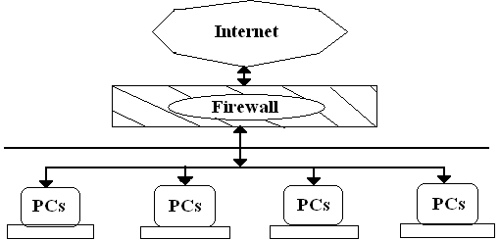

- Encryption :
As we seek to protect hardware, software and Data, if we somehow scramble the data so that interpretation is meaning to the intruder without knowing how to scrambling was done. Indeed the most powerful tool in providing data security is this scrambling or encoding.

Encryption is the formal name for scrambling process. We take the data in their normal, unscrambled state, called clear text / plaintext and transform them so that they are unintelligible to the outside observe.

- Bio-Metric Security :

Recognizing people by their voices, or appearances, and impersonating people by assuming their appearance, was widely known in classical times. Efforts to find physical characteristics that uniquely identify people include the Bertillon Cranial Maps, Fingerprints and DNA sampling. Using such a feature to identify people for a computer would ideally eliminate errors in authentication.

Bio-metrics is the automated measurement of bio-logical or behavioural features that identify a person.

- Disaster Recovery Systems :

Natural and man-made disasters do happen. Hurricanes, Earthquakes, fires, floods, criminal and terrorist acts, and human error can all severely damage an organization’s computing resources.
Many Companies, especially online e-commerce retailers and wholesalers, airlines, banks and internet service providers, for example, are crippled by loosing even a few hours of computing power.
That’s why organizations develop Disaster Recovery Procedures and formalize them in disaster recovery plan.

- Fault Tolerant Systems :

Many firms also use Fault Tolerant computer systems that have redundant processors, peripherals and software that provide a fail-over capability to back up components in the event of system failure.
However, many Fault Tolerant Computer systems offer a fail-soft capability where the computer system can continue to operate at a reduced but acceptable level in the event of a major system failure.

- E-mail Monitoring :

Internet and other online e-mail systems are one of the favourite avenues of attack by hackers for spreading computer viruses or breaking into networked computers. So, the company managers who are concerned about protecting their intellectual property and guarding themselves against litigation go for monitoring software.
The systematic monitoring of corporate e-mail traffic can be done using content – monitoring software, the software scans for troublesome wards that might compromise corporate security.

- Back-Up :

A backup is a copy of all or a part of file to assist in re-establishing a lost file.
In professional computing systems, periodic backups are usually performed automatically. Everything on the system is copied, so that the system can be regenerated after a crisis. This type of Back up is called Complete backup.

- Major installations may perform Revolving Backups, in which the last several backups are kept.
- Another form of Backup is a Selective Backup in which only files that have been changed (or created) since the last backup are saved.

  - Parental Control :

A parental Control technique helps the User to save important data / files from deletion and getting tampered by kids and ignorant users. Thus, it also helps the user to monitor the activity in that particular Computer.

- Digital Signature :

Digital Signature means use of some distinct digits in place of one’s signature.
It is an electronic aid to authenticate the identity of the sender.
It is an extra data attached to a message that identifies & authenticates the sender & ensures that original message is not altered in any manner.
The Digital Signature is created in two distinct steps :
- Message Digest .
- Use of Public key & the corresponding Private Key.

